**TESTPLAN FOR “https://www.oanda.com/currency/converter/ “**

Table of contents:

|  |  |  |  |  |
| --- | --- | --- | --- | --- |
|  | Topics | Pages | Manually Tested | Automation Completed |
| 1. | Assumptions of Test Plan |  |  |  |
| 2. | Testcases |  |  |  |
|  | 2.1 Cookie Notification |  |  |  |
|  | 2.2 Oanda logo |  |  |  |
|  | 2.3 Search, language, sign-in, open an account tab |  |  |  |
|  | 2.4 Trading, currency converter, money transfer, solution for business, resources |  |  |  |
|  | 2.5 Bread crumb navigation |  |  |  |
|  | 2.6 Currency Converter text |  |  |  |
|  | 2.7 Currency Converter Tab |  |  |  |
|  | 2.8 Historical exchange rates, live exchange rates, transfer money Tabs |  |  |  |
|  | 2.9 Personal money [sign-up], Corporate FX payment [learn more], Automated rates API [learn more] and Online Trading platform [Demo Account] |  |  |  |
|  | 2.10 Try Also … |  |  |  |

1. **Assumptions of Test Plan:**

* On the above website page, when ever a button is pressed or a search is done, the result of it is expected as described in UI product requirement document.
* Testing and automation is done on Chrome Browser.

1. **Test cases:**
   1. **Cookie Notification:**

TC1: When above web page loads on the web browser user gets cookie notification. When user click on close button for cookie top header notification.

Expected output: Top header notification should go away.

* 1. **OANDA:**



TC1: User clicks on OANDA sign.

Expected output: The user should be directed to OANDA home page

TC2: User clicks on “OANDA”

Expected output: The user should be directed to OANDA home page

* 1. **Search, language, sign- in, open an account tab:**



**2.3.1 Search Field:**

TC1: Able to search for given string like “API”

Expected output: links for string found or links for string not found should appear in search result window

TC2: From the search results window, when user presses language.

Expected output: The language tab should not be allowed to change

TC3: From the search results window, when user presses sign-in tab.

Expected output: User should be able to navigate to FX-Trade, FX-Trade Practice, money transfer, Exchange rate API, Historical converter login pages

TC4: From the search result window, when user presses “open an account”

Expected output: User should be able to navigate to “live trading account”,” demo trading account”, “corporate trading account”, “money transfer”, “Exchange rate API”, “Historical converter” login pages.

**2.3.2 Language Field:**

Supporting languages: - Chinese, Japanese, English, German, Spanish, French, Italian, Portuguese, Russian

TC1: User chooses a language “Chinese” in the drop down menu

Expected output:

1. The drop down menu should exclude the selected language.
2. Also the page should get translated to selected language.
3. Check that “live exchange rates”, “Mobile Currency Apps”, “[Exchange Rate Feed/API](https://www.oanda.com/rates/currency-data/currency-feed-xml?srccont=rightnav)” and “[Embeddable Converter Widget](https://www.oanda.com/currency/currency-converter-widget)” are in English.

TC2: User choose a language “Japanese” in the drop down menu

Expected output:

1. The drop down menu should exclude the selected language.
2. Also the page should get translated to selected language.
3. Check that “live exchange rates”, “Mobile Currency Apps”, “[Exchange Rate Feed/API](https://www.oanda.com/rates/currency-data/currency-feed-xml?srccont=rightnav)” and “[Embeddable Converter Widget](https://www.oanda.com/currency/currency-converter-widget)” are in English.

TC3: User choose a language “English” in the drop down menu

Expected output:

1. The drop down menu should exclude the selected language.
2. Also the page should get translated to selected language.
3. Check that “live exchange rates”, “Mobile Currency Apps”, “[Exchange Rate Feed/API](https://www.oanda.com/rates/currency-data/currency-feed-xml?srccont=rightnav)” and “[Embeddable Converter Widget](https://www.oanda.com/currency/currency-converter-widget)” are in English.

TC4: User choose a language “German” in the drop down menu

Expected output:

1. The drop down menu should exclude the selected language.
2. Also the page should get translated to selected language.
3. Check that “live exchange rates”, “Mobile Currency Apps”, “[Exchange Rate Feed/API](https://www.oanda.com/rates/currency-data/currency-feed-xml?srccont=rightnav)” and “[Embeddable Converter Widget](https://www.oanda.com/currency/currency-converter-widget)” are in English.

TC5: User choose a language “Spanish” in the drop down menu

Expected output:

1. The drop down menu should exclude the selected language.
2. Also the page should get translated to selected language.
3. Check that “live exchange rates”, “Mobile Currency Apps”, “[Exchange Rate Feed/API](https://www.oanda.com/rates/currency-data/currency-feed-xml?srccont=rightnav)” and “[Embeddable Converter Widget](https://www.oanda.com/currency/currency-converter-widget)” are in English.

TC6: User choose a language “French” in the drop down menu

Expected output:

1. The drop down menu should exclude the selected language.
2. Also the page should get translated to selected language.
3. Check that “live exchange rates”, “Mobile Currency Apps”, “[Exchange Rate Feed/API](https://www.oanda.com/rates/currency-data/currency-feed-xml?srccont=rightnav)” and “[Embeddable Converter Widget](https://www.oanda.com/currency/currency-converter-widget)” are in English.

TC7: User choose a language “Italian” in the drop down menu

Expected output:

1. The drop down menu should exclude the selected language.
2. Also the page should get translated to selected language.
3. Check that “live exchange rates”, “Mobile Currency Apps”, “[Exchange Rate Feed/API](https://www.oanda.com/rates/currency-data/currency-feed-xml?srccont=rightnav)” and “[Embeddable Converter Widget](https://www.oanda.com/currency/currency-converter-widget)” are in English.

TC8: User choose a language “Portuguese” in the drop down menu

Expected output:

1. The drop down menu should exclude the selected language.
2. Also the page should get translated to selected language.
3. Check that “live exchange rates”, “Mobile Currency Apps”, “[Exchange Rate Feed/API](https://www.oanda.com/rates/currency-data/currency-feed-xml?srccont=rightnav)” and “[Embeddable Converter Widget](https://www.oanda.com/currency/currency-converter-widget)” are in English.

TC9: User choose a language “Russian” in the drop down menu

Expected output:

1. The drop down menu should exclude the selected language.
2. Also the page should get translated to selected language.
3. Check that “live exchange rates”, “Mobile Currency Apps”, “[Exchange Rate Feed/API](https://www.oanda.com/rates/currency-data/currency-feed-xml?srccont=rightnav)” and “[Embeddable Converter Widget](https://www.oanda.com/currency/currency-converter-widget)” are in English.

**2.3.4 Sign-in:**

TC1: User clicks on sign-in

Expected output:

Notification menu for Sign-in of FX-Trade, FX-Trade Practice, money transfer, Exchange rate API, Historical converter login should be seen

TC2: User clicks on the close button of sign-in

Expected Output:

Top header notification menu should go away

TC3: User clicks on the “FX-Trade”

Expected Output: User should be redirected to the correct login page and correct web title.

TC4: User clicks on the “FX-Trade Practice”

Expected Output: User should be redirected to the correct login page and correct web title.

TC5: User clicks on “money transfer”

Expected Output: User should be redirected to correct login page and correct web title.

TC6: User clicks on “Exchange rate API”

Expected Output: User should be redirected to correct login page and correct web title.

TC7: User clicks on “Historical converter”

Expected Output: User should be redirected to correct login page and correct web title.

**2.3.5 Open an account:**

TC1: User clicks on Open an account

Expected output:

Notification for open account menu of “live trading account”, “demo trading account”, “corporate trading account”, “money transfer”, “Exchange rate API”, “Historical converter” login should be seen

TC2: User clicks on the close button of sign-in

Expected Output:

Top header notification menu should go away

TC3: User clicks on the “live trading account”

Expected Output: User should be redirected to the correct login page and correct web title.

TC4: User clicks on the “demo trading account”

Expected Output: User should be redirected to the correct login page and correct web title.

TC5: User clicks on “corporate trading account”

Expected Output: User should be redirected to the correct login page and correct web title.

TC6: User clicks on “money transfer”

Expected Output: User should be redirected to correct login page and correct web title.

TC7: User clicks on “Exchange rate API”

Expected Output: User should be redirected to correct login page and correct web title.

TC8: User clicks on “Historical converter”

Expected Output: User should be redirected to correct login page and correct web title.

* 1. **Trading,currency converter,money transfer, solution for business, resources:**



* + 1. **Trading:**

TC1:User clicks on Trading

Expected output:

1. drop down menu of “Trading overview, why OANDA, markets,platforms, Tools,Analysis,Learn”
2. Check that it hides the bread crumb “[Home](https://www.oanda.com/) > [Currency Tools](https://www.oanda.com/currency/) > Currency Converter”

TC2: User again clicks on Trading

Expected Output: drop menu closes or goes away

TC3: User clicks on white page to close Trading drop down

Expected Output: drop menu for Trading should not close.

TC4: User clicks on “Trading overview” in TRADING link

Expected Output: User should be redirected to correct webpage and correct browser title

TC5: User clicks on “why OANDA” in TRADING link

Expected Output: User should be redirected to correct webpage and correct browser title

TC6: User clicks on “markets plaforms” in TRADING link

Expected Output: User should be redirected to correct webpage and correct browser title

TC7: User clicks on “Tools” in TRADING link

Expected Output: User should be redirected to correct webpage and correct browser title

TC8: User clicks on currency converter or resources

Expected output: drop down menu for currency converter or recourses should open

* + 1. **Currency Converter**

TC1: User clicks on converter link

Expected Output: User should be redirected to correct webpage and correct browser title

TC2: User clicks on Tools

Expected Output: User should be redirected to correct webpage and correct browser title

TC3: User clicks on Mobile

Expected Output: User should be redirected to correct webpage and correct browser title

TC4: User click on Live Rates

Expected Output: User should be redirected to correct webpage and correct browser title

TC5: User click on Historical Rates

Expected Output: User should be redirected to correct webpage and correct browser title

TC6: User click on Embed Converter

Expected Output: User should be redirected to correct webpage and correct browser title

TC7: User click on Help

Expected Output: User should be redirected to correct webpage and correct browser title

* + 1. **Money Transfer**

TC1: User clicks on Individual

Expected Output: User should be redirected to correct webpage and correct browser title

TC2: User clicks on Business

Expected Output: User should be redirected to correct webpage and correct browser title

* + 1. **Solution for Business**

TC1: User clicks on “FX on Business Overview”

Expected Output: User should be redirected to correct webpage and correct browser title

TC2: User click on “Exchange Rate API”

Expected Output: User should be redirected to correct webpage and correct browser title

TC3: User clicks on “Corporate FX Payments”

Expected Output: User should be redirected to correct webpage and correct browser title

TC4: User clicks on “Historical currency converter”

Expected Output: User should be redirected to correct webpage and correct browser title

TC5: User clicks on “Contact US”

Expected Output: User should be redirected to correct webpage and correct browser title

TC6: User clicks on “Blog”

Expected Output: User should be redirected to correct webpage and correct browser title

* + 1. **Resources**

TC1: User clicks on “Resource Overview”

Expected Output: User should be redirected to correct webpage and correct browser title

TC2: User clicks on “Legal”

Expected Output: User should be redirected to correct webpage and correct browser title

TC3: User click on “Support”

Expected Output: User should be redirected to correct webpage and correct browser title

TC4: User clicks on “News”

Expected Output: User should be redirected to correct webpage and correct browser title

TC5: User clicks on “Product Launches”

Expected Output: User should be redirected to correct webpage and correct browser title

TC6: User clicks on “contact Us”

Expected Output: User should be redirected to correct webpage and correct browser title

* 1. **Bread crumb navigation:**

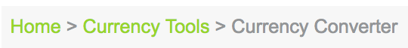

TC1: User clicks on currency tools in bread crumb navigation

Expected Output: User should be redirected to correct webpage and correct browser title

TC2: User clicks on home in bread crumb navigation

Expected Output: User should be redirected to correct webpage and correct browser title

* 1. **Currency Converter text:**



N/A

* 1. **Currency Converter Tab:**

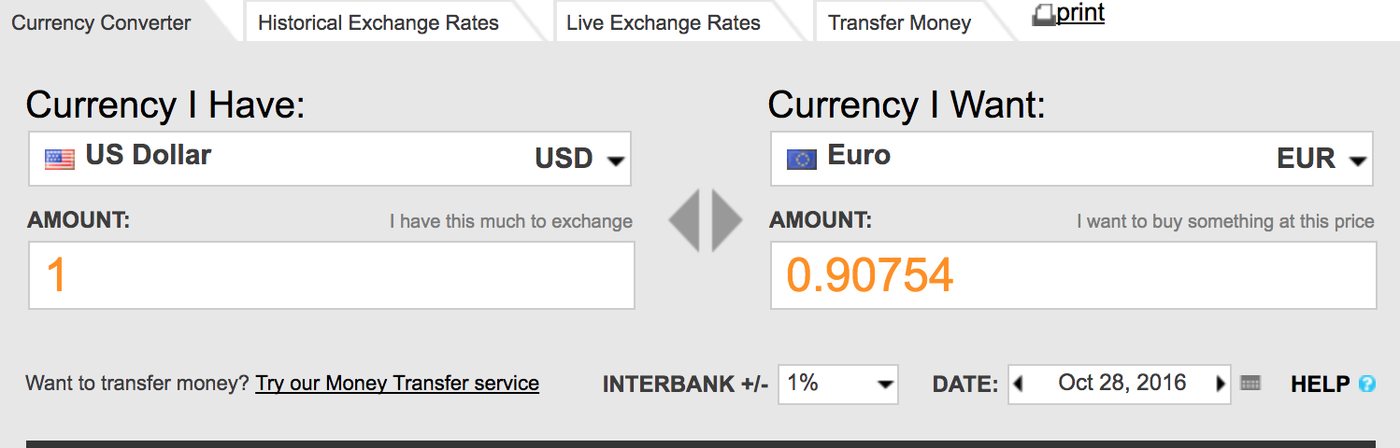

TC1: User click drop down of currency I have

Expected output: should be able to search for any currency

Testing Status: Manual Testing (already covered in automation in TC8)

TC2: User click drop down of currency I want

Expected output: should be able to search for any currency

Testing Status: Manual Testing (already covered in automation in TC8)

TC3: User clicks on currency with (*) at the end

Expected output: User should see a warning sign – “Warning: ADF Andorran Franc is replaced by the Euro. [Read more about the Euro.](https://www.oanda.com/site/euro.shtml)”

Testing Status: Manual Testing

TC4: check that drop down menu for currency I want is same as currency I have

Testing Status: Manual Testing

TC5: When user clicks the triangles in between “currency I want” and “currency I have” search boxes

Expected output:

1. It should change currency I have to currency I want
2. The last entered amount box should stay as is and adjacent amount box should update the value according to the above change

Testing Status: Automated Testing

TC6: User empties an amount box

Expected Output: Adjacent amount box should show 0.00000

Testing Status: Automated Testing

TC7: Check User should be able to type any character on the keyboard in both the amount boxes

Testing Status: Manual Testing (already covered in automation in TC8)

TC8:

Testing Status: Automated Testing

|  |  |  |  |  |  |  |
| --- | --- | --- | --- | --- | --- | --- |
| **Test Item** | **Test Data** | **Actual Result** | **Expected Result** | **Type of Test** | **Date** | **Interbank** |
| Currency I have box – INR  Currency I want box –  USD | 1 dollar |  | 64.3842 – max five float point numbers | Positive | 28th Oct 2017 | 1% |
| Currency I have box - USD  Currency I want box –  Euro | -2 dollar |  | 128.768– takes the absolute value | negative | 28th Oct 2016 | 1% |
| Currency I have box - USD  Currency I want box –  Indian currency | “strposfkwe” |  | - | Negative | 28th Oct 2017 | 5% |
| Currency I have box - USD  Currency I want box –  Indian currency | “#$#$#” |  | - | Negative | 28th Oct 2017 | 1% |
| Currency I have box – EURO  Currency I want box –  JPY | 500 in amount of Currency I want box |  | 3.81548 expected in amount of Currency I have box | Negative | 28th Oct 2017 | 1% |
| Currency I have box – EURO  Currency I want box –  eere | 500 in amount of Currency I want box | Takes random currency in “currency I want” box | **CANNOT VERIFY SINCE BEHAVIOR IS RANDOM | Negative | 28th Oct 2017 | 1% |

TC9: User clicks on “ [Try our Money Transfer service](https://www.oanda.com/money-transfer/)”

Expected output: page should be directed to expected url and also check for the title of the webpage

Testing Status: Automated Testing

TC10: User clicks on interbank

Expected output: Should be able see +/-0% to +/-5%

Testing Status: Manual Testing

TC11: User clicks on the date/ calendar icon

Expected Output:

1. Calendar should drop down
2. User should not be able to go beyond todays date
3. Today date should be always shown at the end

Testing Status: Automated Testing

TC12: User clicks on the close button of the date

Expected Output: Should be able to close the calendar.

Testing Status: Manual Testing

TC13: User clicks on a date other than todays date

Expected Output:

1. calendar closes and the date is filled
2. Amount box shows expected amount
3. Show both right and left arrow

Testing Status: Automated Test as part of TC8

TC14: User clicks on the arrows of the calendar box

Expected Output:

1. When click left button, the date should move backward for todays date
2. When click right button from a back date, it should move to following date

Testing Status: Manual Testing

TC15: User clicks on present date

Expected Output:

1. calendar closes and the date is filled
2. Amount box shows expected amount
3. Show only left arrow

Testing Status: Automated Test as part of TC11

TC16: User clicks on Help (?) icon

Expected Output: This should direct the user to currency converter help page.

Testing Status: Automated Testing

* 1. **Historical exchange rates, live exchange rates, transfer money:**



TC1: User clicks on “Historical exchange rates” Tab

Expected Output: User should be redirected to correct webpage and correct browser title

TC2: User clicks on “Lives Exchanges Rates” Tab

Expected Output: User should be redirected to correct webpage and correct browser title

TC3: User clicks on “Transfer Money” Tab

Expected Output: User should be redirected to correct webpage and correct browser title

TC4: User clicks on “print” button

Expected Output: User should be shown a static page to print the website <https://www.oanda.com/currency/converter/>

Issue seen: Since the static page url is same and website url, when navigation is done back and forth User always lands up on static print page instead of the actual webpage

* 1. **Personal money [sign-up], Corporate FX payment [learn more], Automated rates API [learn more] and Online Trading platform [Demo Account]**

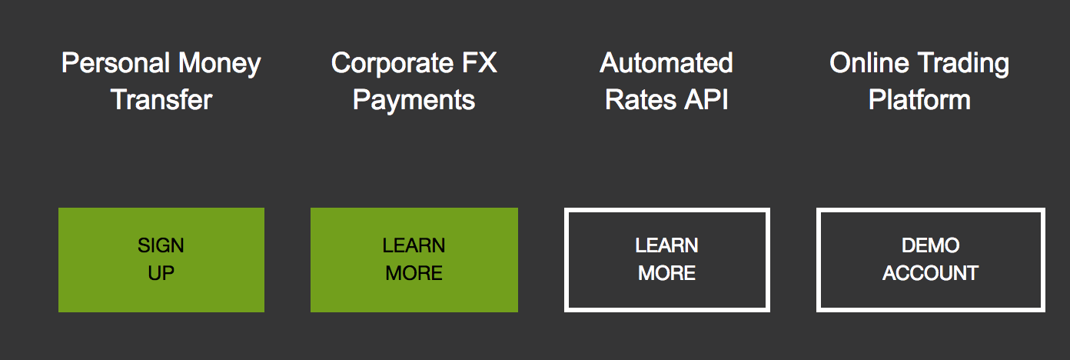

TC1: User mouse goes on to personal money sign-up box

Expected Output: change the box color to lighter shade to give highlight effect

TC2: User clicks on personal money sign-up box

Expected Output: User should be redirected to correct webpage and correct browser title

TC3: User mouse goes on to corporate FX payment learn more box

Expected Output: change the box color to lighter shade to give highlight effect

TC4: User clicks on corporate FX payment learn more box

Expected Output: User should be redirected to correct webpage and correct browser title

TC5: User mouse goes on to automated rates API learn more box

Expected Output: change the box color to lighter shade to give highlight effect

TC6: User clicks on automated rates API learn more box

Expected Output: User should be redirected to correct webpage and correct browser title

TC7: User mouse goes on to online trading platform demo account box

Expected Output: change the box color to lighter shade to give highlight effect

TC8: User clicks on online trading platform demo account box

Expected Output: User should be redirected to correct webpage and correct browser title

* 1. **TRY ALSO...**

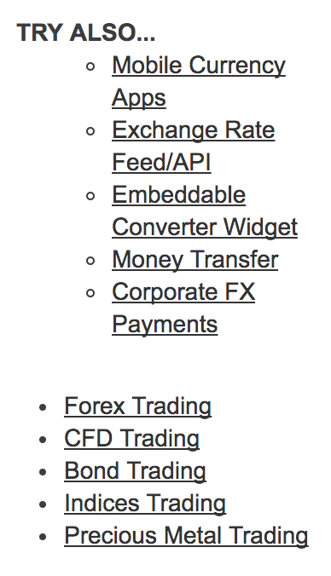

TC1: User clicks on “Mobile Currency Apps”

Expected Output: User should be redirected to correct webpage and correct browser title

TC2: User clicks on “Exchange Rate Feed/API”

Expected Output: User should be redirected to correct webpage and correct browser title

TC3: User clicks on “Embeddable Converter Widget”

Expected Output: User should be redirected to correct webpage and correct browser title

TC4: User clicks on “Money Transfer”

Expected Output: User should be redirected to correct webpage and correct browser title

TC5: User clicks on “Corporate FX Payments”

Expected Output: User should be redirected to correct webpage and correct browser title

TC6: User clicks on “Forex Trading”

Expected Output: User should be redirected to correct webpage and correct browser title

TC7: User clicks on “CFD Trading”

Expected Output: User should be redirected to correct webpage and correct browser title

TC8: User clicks on “Bond Trading”

Expected Output: User should be redirected to correct webpage and correct browser title

TC9: User clicks on “Indices Trading”

Expected Output: User should be redirected to correct webpage and correct browser title

TC10: User clicks on “Precious Metal Trading”

Expected Output: User should be redirected to correct webpage and correct browser title